**Practical No. 6**

**Replication Using MongoDB**

**Step 1: Create folder in c drive.**

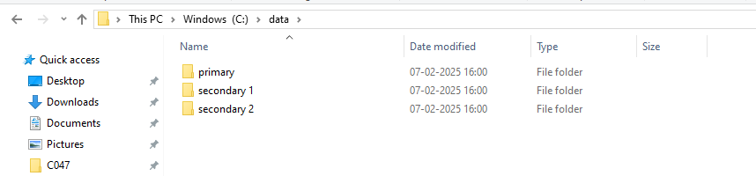

**Step 2: Go to Windows PowerShell ISE>New file(make three of them/ type same command with different port and path)**

**Commands:**

mongod --port=2717 --dbpath="C:\data\primary" --replSet="test-replica-set"

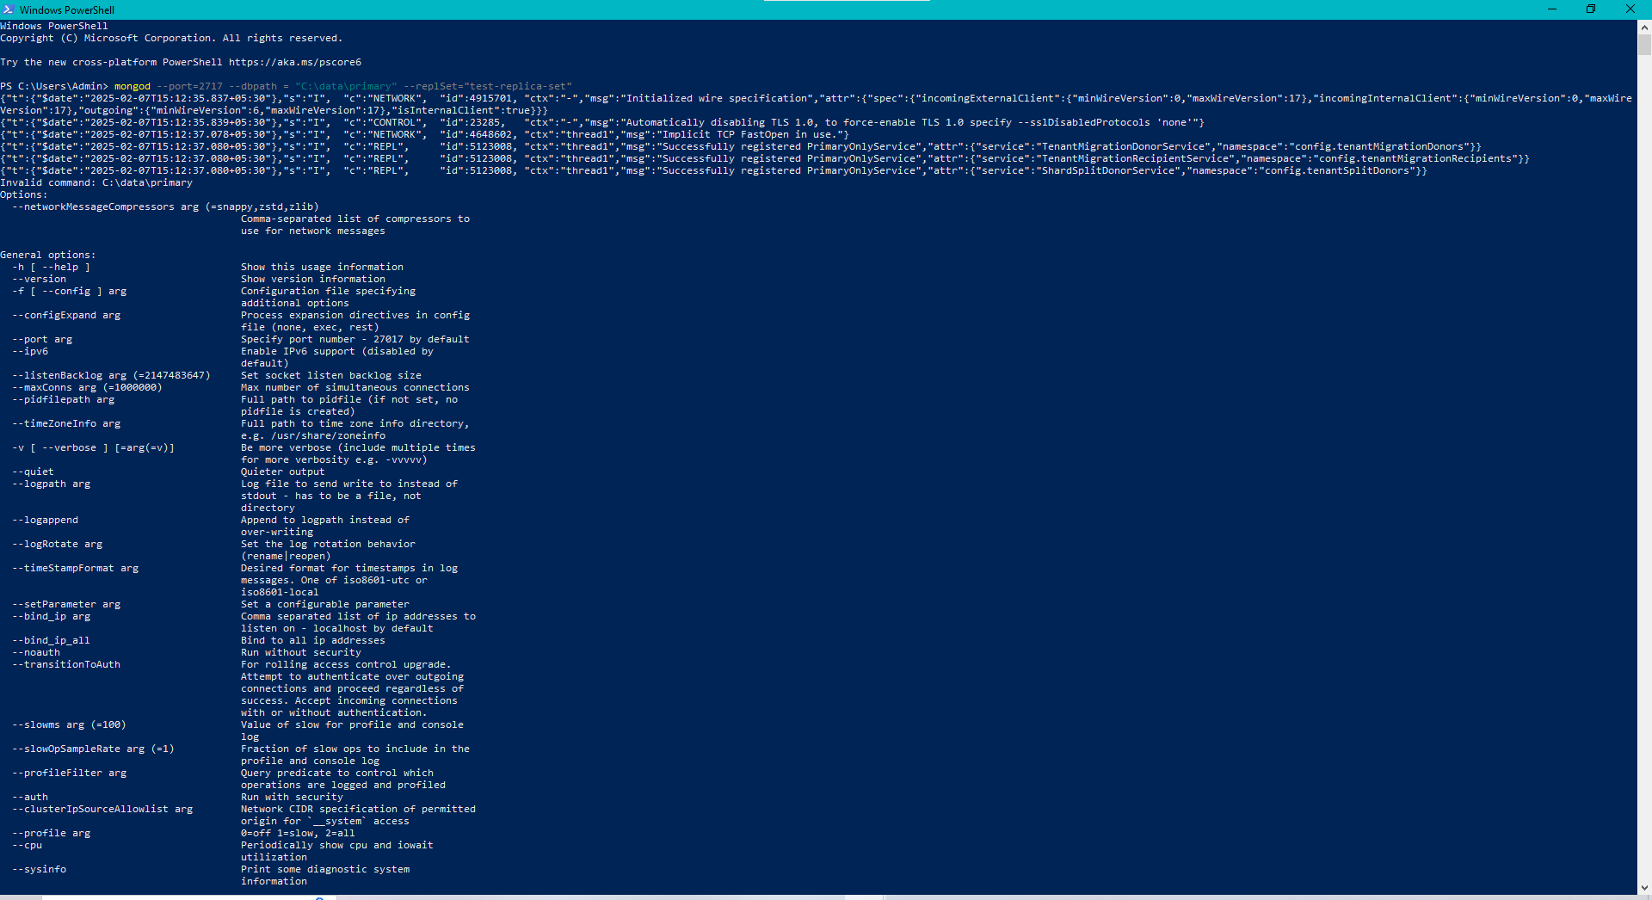

mongod --port=2727 --dbpath = "C:\data\secondary 1" --replSet="test-replica-set"

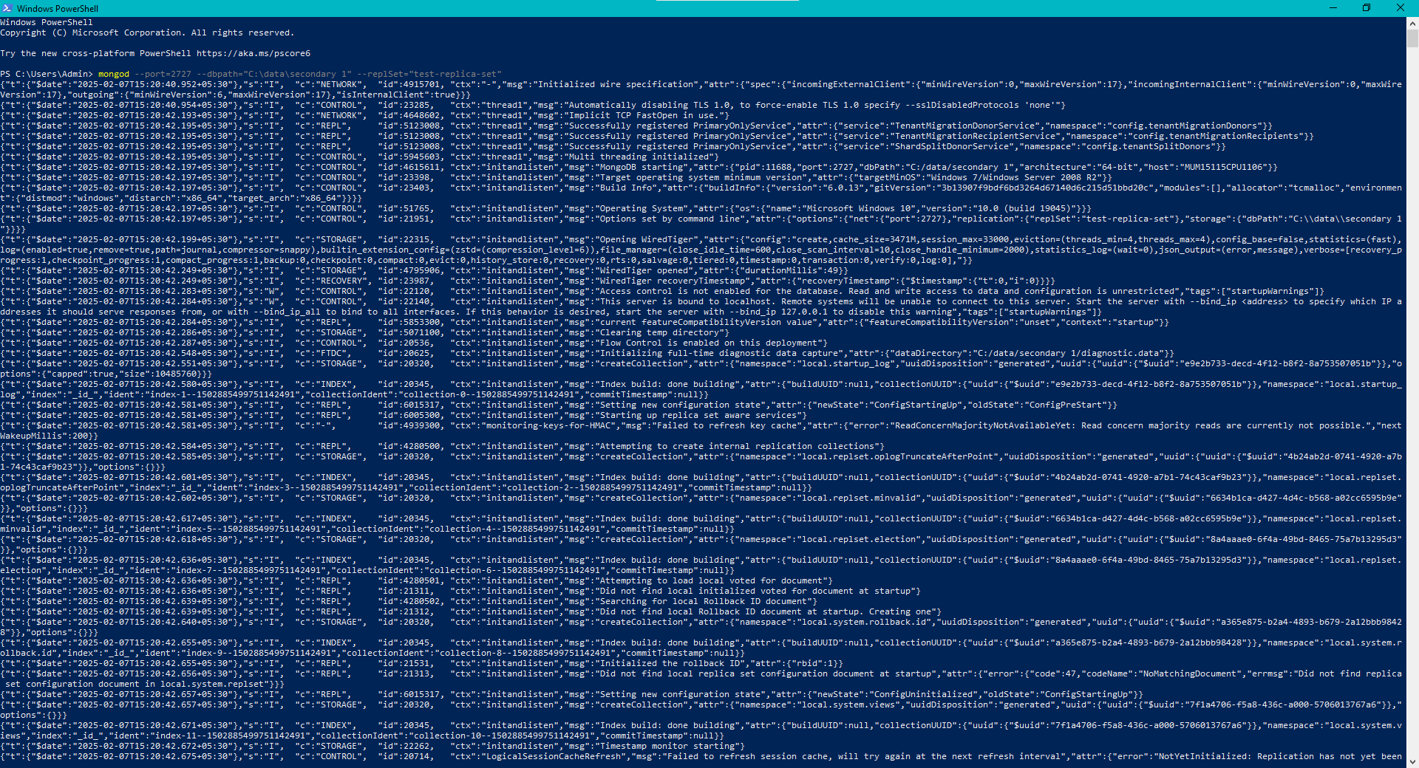

mongod --port=2737 --dbpath = "C:\data\secondary 2" --replSet="test-replica-set"

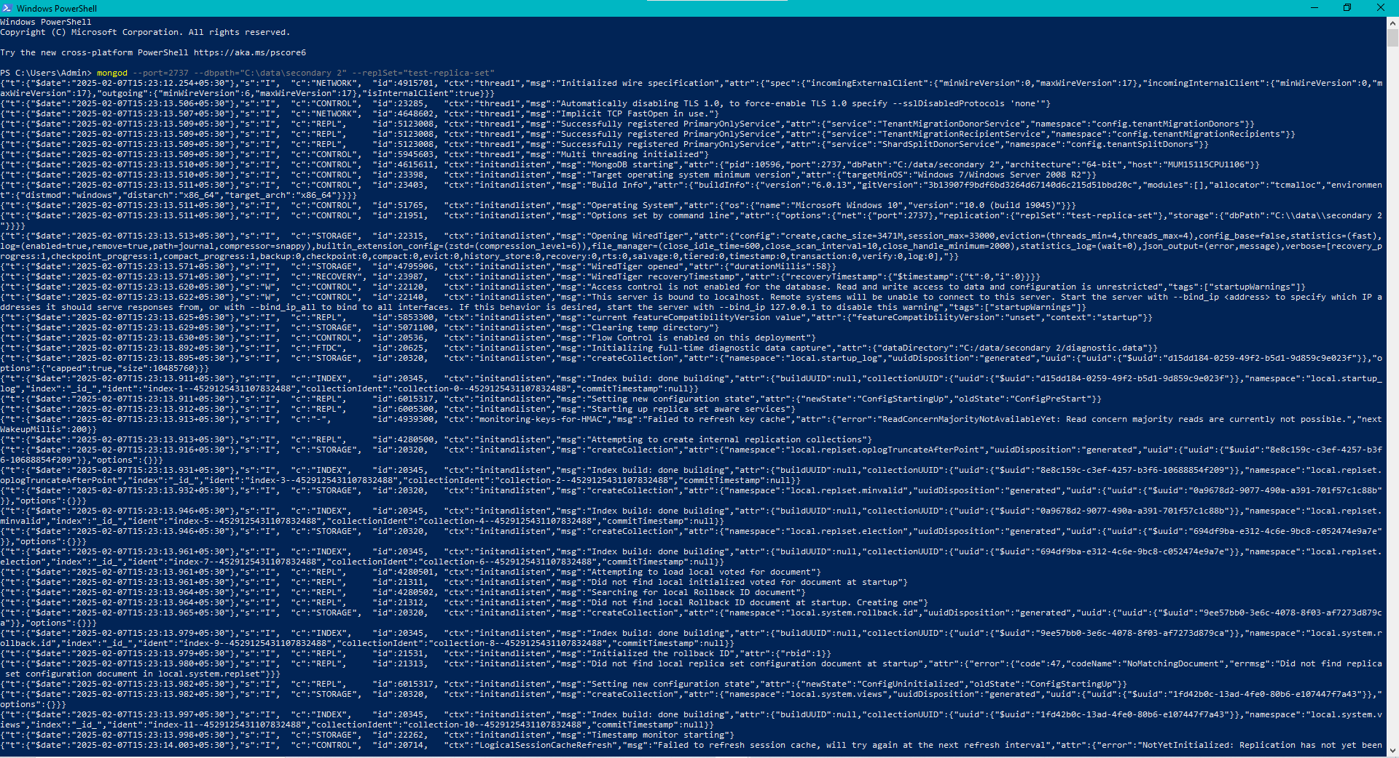

**Step 3: New window**

**Commands:**

mongosh --host="localhost:2717" (make new 2 windows with other localhost)

rs.initiate()

rs.add({“host:localhost:2727”});

rs.status()

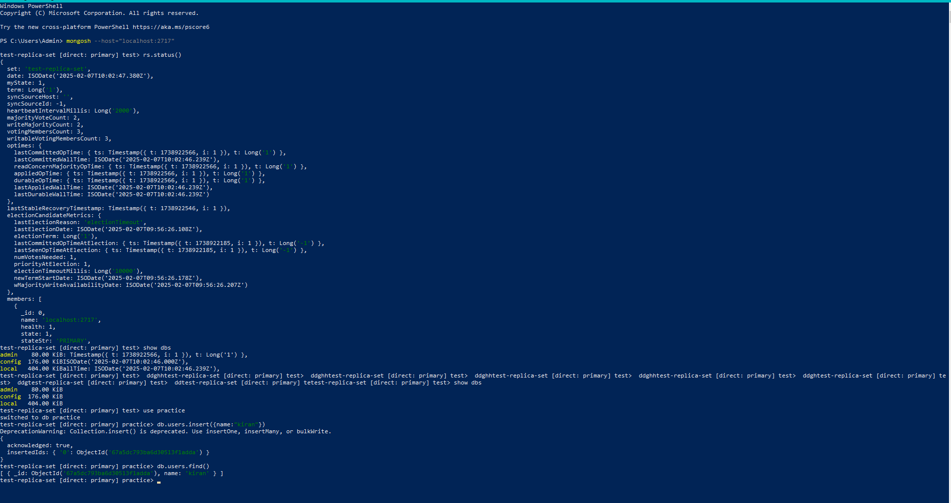

**Step 4: Type following commands on Localhost: 2717’s window.**

1. **show dbs**
2. **use practice**
3. **db.users.insert({name:"kiran "})**
4. **db.users.find()**

Localhost: 2717

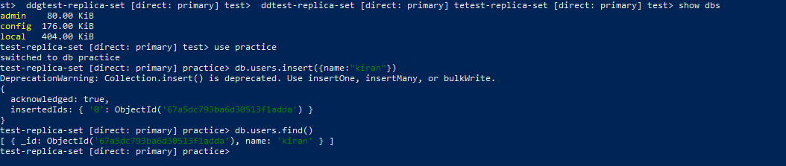

Now repeat commands 1, 2, 4 for rest 2 windows

Localhost:2727

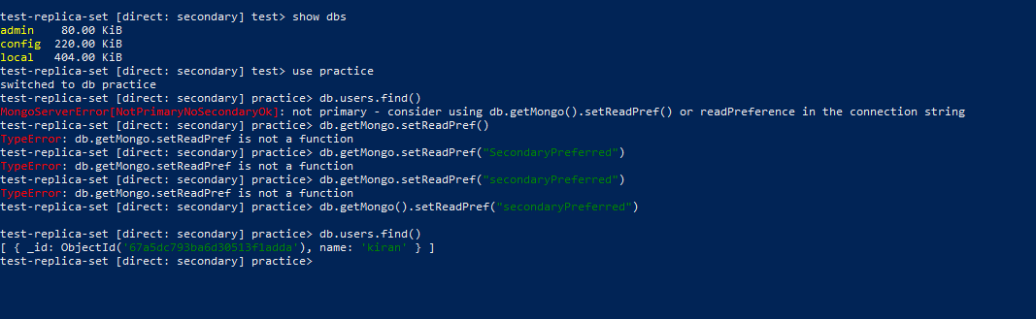

Localhost:2737

